C:\Users\klaho028\Downloads\SEG2105-Project-master\SEG2105-Project-master\Deliverable1\UML Class diagram\UML\Pics\many.pngC:\Users\klaho028\Downloads\SEG2105-Project-master\SEG2105-Project-master\Deliverable1\UML Class diagram\UML\Pics\many.pngC:\Users\klaho028\Downloads\SEG2105-Project-master\SEG2105-Project-master\Deliverable1\UML Class diagram\UML\Pics\many.pngC:\Users\klaho028\Downloads\SEG2105-Project-master\SEG2105-Project-master\Deliverable1\UML Class diagram\UML\Pics\1.pngC:\Users\klaho028\Downloads\SEG2105-Project-master\SEG2105-Project-master\Deliverable1\UML Class diagram\UML\Pics\0to1.pngC:\Users\klaho028\Downloads\SEG2105-Project-master\SEG2105-Project-master\Deliverable1\UML Class diagram\UML\Pics\0to1.png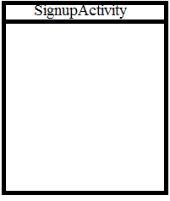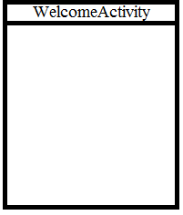 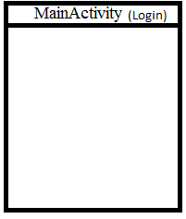

C:\Users\klaho028\Downloads\SEG2105-Project-master\SEG2105-Project-master\Deliverable1\UML Class diagram\UML\Pics\1tmany.png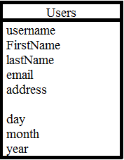

C:\Users\klaho028\Downloads\SEG2105-Project-master\SEG2105-Project-master\Deliverable1\UML Class diagram\UML\Pics\many.pngC:\Users\klaho028\Downloads\SEG2105-Project-master\SEG2105-Project-master\Deliverable1\UML Class diagram\UML\Pics\0to1.pngC:\Users\klaho028\Downloads\SEG2105-Project-master\SEG2105-Project-master\Deliverable1\UML Class diagram\UML\Pics\0to1.pngC:\Users\klaho028\Downloads\SEG2105-Project-master\SEG2105-Project-master\Deliverable1\UML Class diagram\UML\Pics\many.pngC:\Users\klaho028\Downloads\SEG2105-Project-master\SEG2105-Project-master\Deliverable1\UML Class diagram\UML\Pics\many.pngC:\Users\klaho028\Downloads\SEG2105-Project-master\SEG2105-Project-master\Deliverable1\UML Class diagram\UML\Pics\many.pngC:\Users\klaho028\Downloads\SEG2105-Project-master\SEG2105-Project-master\Deliverable1\UML Class diagram\UML\Pics\many.pngC:\Users\klaho028\Downloads\SEG2105-Project-master\SEG2105-Project-master\Deliverable1\UML Class diagram\UML\Pics\many.pngC:\Users\klaho028\Downloads\SEG2105-Project-master\SEG2105-Project-master\Deliverable1\UML Class diagram\UML\Pics\many.pngC:\Users\klaho028\Downloads\SEG2105-Project-master\SEG2105-Project-master\Deliverable1\UML Class diagram\UML\Pics\many.pngC:\Users\klaho028\Downloads\SEG2105-Project-master\SEG2105-Project-master\Deliverable1\UML Class diagram\UML\Pics\many.png